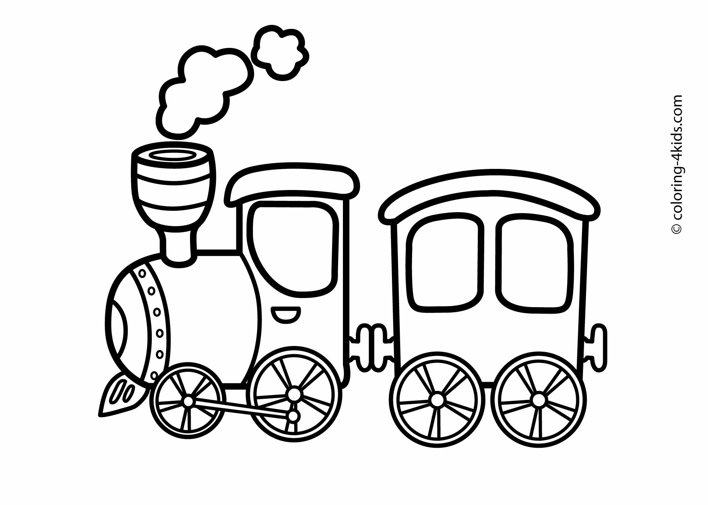

My train is going to ________________________

Name: